D387 – Advanced Java

C2 - Docker name screenshot
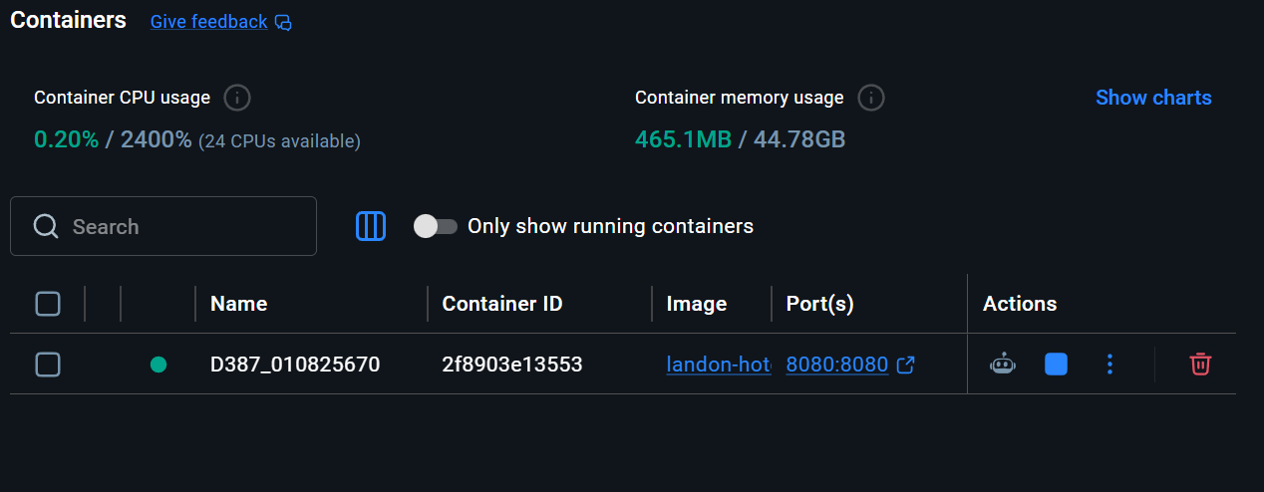

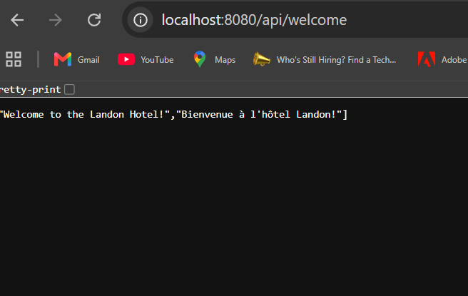

C3 – Describe how you would deploy the current multithreaded Spring application to the cloud. Include the name of the cloud service provider you would use.
To deploy this Spring Boot and Angular application to a cloud environment, I would utilize Amazon Web Services specifically leveraging AWS Elastic Beanstalk. This approach is ideal because it automates the management of the underlying infrastructure, allowing the service to handle capacity provisioning, load balancing, and health monitoring for the Dockerized application.
The deployment workflow would follow these steps:
- Image Repository: After building the Docker image locally, I would push it to the Amazon Elastic Container Registry (ECR). This provides a secure, private repository to host the application blueprint.
- Environment Setup: Using AWS Elastic Beanstalk, I would configure a new environment specifically optimized for Docker containers. Elastic Beanstalk would take the image from ECR and automatically deploy it onto EC2 instances.
- Database Migration: Since the current application uses an in-memory H2 database, I would transition to Amazon RDS (Relational Database Service). This would provide a persistent, production-grade SQL database that ensures hotel reservation data is not lost when the container restarts.
- CI/CD Integration: I would implement a CI/CD pipeline using GitLab CI/CD. Every time I push code to the repository, the pipeline would automatically trigger a build, create a new Docker image, push it to ECR, and signal Elastic Beanstalk to perform a "rolling update" to the live production environment with zero downtime.

